CMIT 369 Windows Server: Install and Storage

Windows Server 2016 Virtual Installation

UMUC

Dmitry Landy

December 3, 2019

Windows Server 2016 Virtual Installation

This guide will describe the steps necessary to install Windows Server 2016 as well as some additional services it can provide. During the installation process, an edition of Windows Server 2016 will have to be chosen. There are three main editions of Windows Server 2016: Essentials, Standard, and Datacenter (TestOut Corp, 2.2.1). Essentials is used in small organizations due to the limited number of users and devices it can support. Essentials can only be deployed on a single server with no more than two processors and no more than 64 TB of RAM. Standard and Datacenter versions are used in medium to large organizations and can service an unlimited amount of users and devices. They support up to 512 CPU cores, 24 TB of RAM, Server core installation, and have Hyper-V support. The difference between the two is that the Standard edition can only have up to two virtual instances of it on a server, while the Datacenter version has no limits. Each version can be deployed as a server core or a normal desktop experience. Server core allows for a less intensive deployment since it does not include a graphical interface. Instead, all of its functionality is accessed using the command-line interface.

This report will walk through and discuss the various steps of installing Windows Server 2016 Standard edition with the desktop environment and will give the user a basic understanding of the operating systems as well as some of the services it can provide. This installation will use Oracle VM VirtualBox. The virtual machine will have one 20 GB hard drives and will boot from the ISO file. This report will discuss the ISO image download, installation process, two PowerShell commands, Active Directory installation and configuration, Internet Information Services installation, and two browser installations.

**ISO Image Download**

An ISO image/file is an archive file that contains the same image as an optical disk, which in this case is a Windows Server 2016 disk (Gavin, 2018). To locate and download the Windows Server 2016 ISO image, follow the steps below:

1. Open a web browser and go to “https://www.microsoft.com/en-us/evalcenter/evaluate-windows-server-2016”.
2. Scroll down and expand “Windows Server 2016”.
3. Expand “start your evaluation”
4. Select and download the ISO file

After the ISO file is downloaded, it will need to be transferred onto storage media so it can be installed (TestOut Corp, 2.2.4). This media can include an optical disk, a flash drive, or a hard drive. After the ISO file is on the storage media, that storage media will have to be inserted into the computer and the BIOS have to be configured to boot from the storage device to begin the installation process.

**Installation Process**

After the ISO file has been downloaded, the installation process can begin by booting from the storage device the ISO file is on (TestOut Corp, 2.2.4). After the computer has fully loaded, a “windows setup” screen will appear that will prompt the user to select the language, time zone, and keyboard layout.

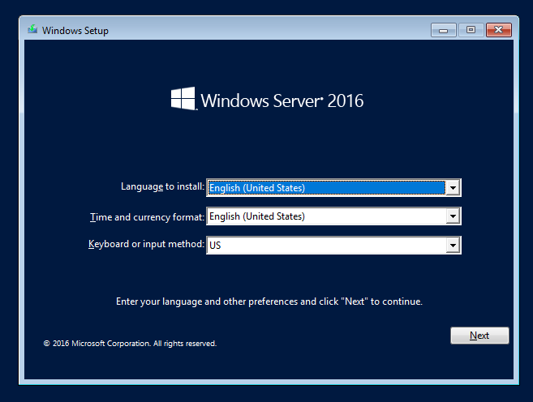

*Figure 1.* Initial screen before operating system installation

After the language, time/currency, and keyboard format have been selected, click “next” and then “Install Now”. This will proceed to the next step where the version and type (desktop or core) will have to be selected. The amount of virtualization being done as well as the hardware resources used will determine the selection.

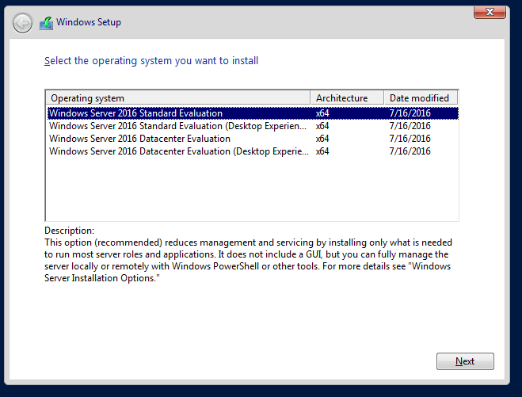

*Figure 2.* Title

The next screen describes the license terms and will need a checkmark to be selected by “I accept the license terms” to continue. The screen after present the user with a choice to upgrade the current system or to have a custom installation. The upgrade option is used to upgrade an older version of Windows Server to the one being installed. The custom option, which is the one used for this report, is to install from scratch.

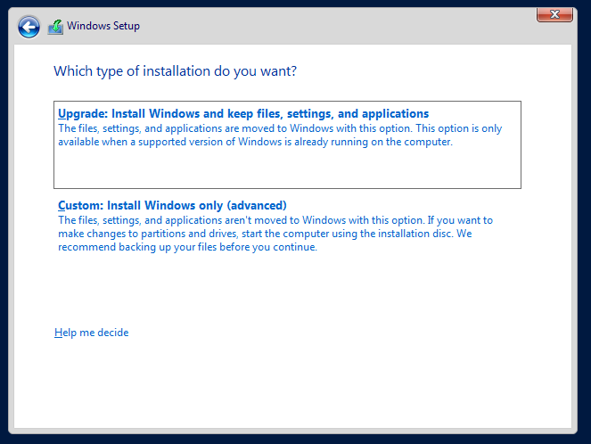

*Figure 3.* Installation type selection window

The next step gives the user an option to select the disk that the operating system will be installed on. If there are multiple disks, then one will need to be selected to house the operating system files. If there are no disks shown when there should be then that could be because the disk is not properly connected or because the driver for the disk is not available (TestOut Corp, 2.2.4). If the driver is not available, then the driver for it will need to be downloaded and placed on removable media, such as a flash drive. That media will need to be connected to the computer and then loaded from by clicking on the “load driver” icon.

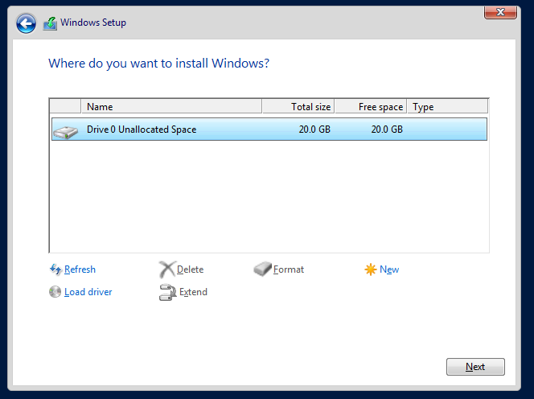

*Figure 4.* Drive partitioning window

As long as the disk can be recognized, it can be partitioned. Each disk can have multiple partitions created on it. To do this, select the “new” icon in the bottom right and then select the amount of memory (in MB) for the new partition. After the disk or disks have been properly partitioned as needed, the next screen will install the operating system, features, and updates which will take some time. When the operating system has been installed on the drive, the local administrator account will need to be configured by setting up the password. That password does have to meet the password complexity criteria to be accepted. After the password is set, the computer name can be changed.

Changing the computer name immediately after installation is important to properly identify it on the network and prevent the difficulties of changing it later (TestOut Corp, 2.2.4). The computer name can be changed by going to “Local Server” in Server Manager and selecting the computer name. A screen will appear with a “change” button to change the computer name.

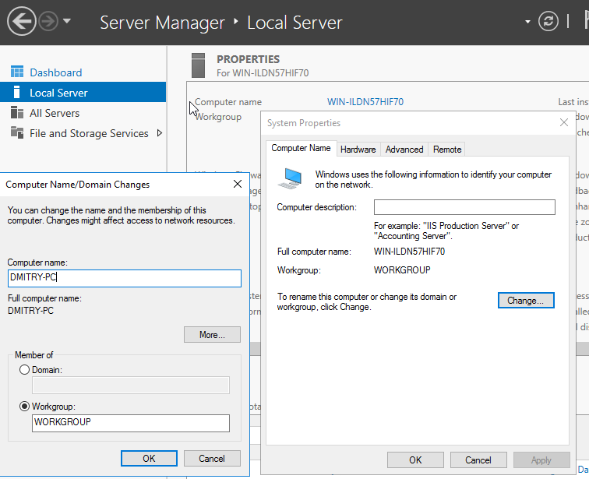

*Figure 5.* Computer name customization

When the computer name is changed, the system will have to be restarted. To restart the computer, locate the Windows start icon in the bottom left of the screen, click the power button icon, and select “Restart”.

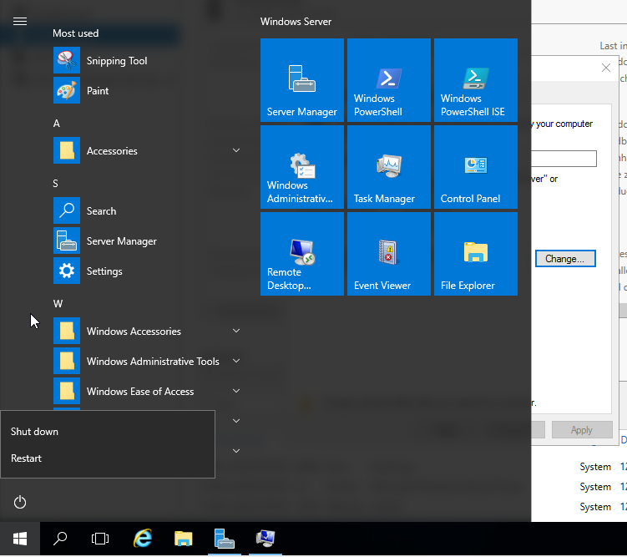

*Figure 6.* Restart function in Windows start Icon

**PowerShell**

To provide an increase in performance to a server, the server core option can be used instead of the desktop experience during the installation process. This server deployment type will require a proper understanding of PowerShell. Even a desktop deployment will require an understanding of PowerShell. PowerShell is a Windows command-line shell utility designed to perform administrative tasks (Microsoft, 2017). Instead of commands, PowerShell uses cmdlets to manage computers.

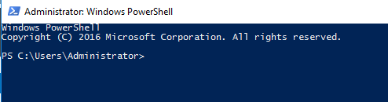

*Figure 7.* Windows PowerShell interface

To use PowerShell in a desktop environment, click the Windows start icon and select the Windows PowerShell tile on the right side (TestOut Corp, 3.1.2). In a server core environment, PowerShell can be accessed by typing “powershell” in the command prompt. The PowerShell interface can be identified by the “PS” on the command line. Once the PowerShell interface has been accessed, cmdlets can be input. The two cmdlets that will be discussed are “get-process” and “stop-process”.

To get information about current processes running on the computer, the “get-process” cmdlet can be used (TestOut Corp, 3.1.2). It can be used by typing “get-process” and a list of all the current processes will be displayed in a table. This table is organized by displaying a few columns of information: Handles, NPM, PM, WS, CPU, ID, SI, and ProcessName. To target a specific process, the “get-process -ID” option with the ID number (Posey, 2016). This will result in the display of process information specific to the process with that ID number. To get even more information about the process, the output can be piped with “select-object *”, such as get-process -ID 512 | select-object *”. The asterisks can be replaced with other options to specify what information about the process is wanted.

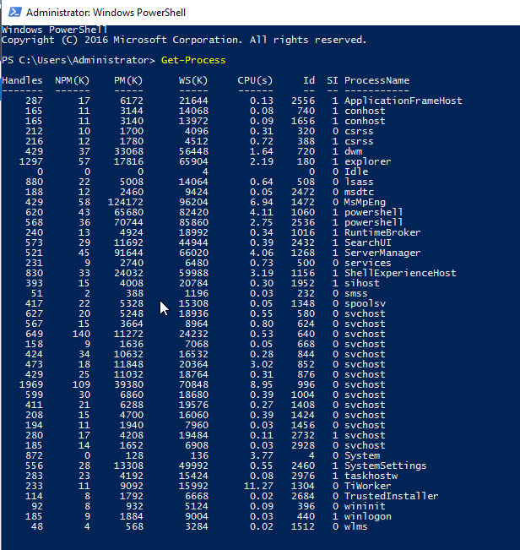

*Figure 8.* Get-Process cmdlet result display

To stop a process currently running, the “stop-process” cmdlet can be used in a PowerShell environment (Tkachenko, 2016). A process can be terminated by specifying the name or the ID of the process. This is done by first identifying the process with the “get-process” command, which will show both the IDs and names of processes currently running. After the process has been identified, the “stop-process” cmdlet followed by the ID number. To terminate a process using the name, “stop-process -processname” followed by the process name will need to be used.

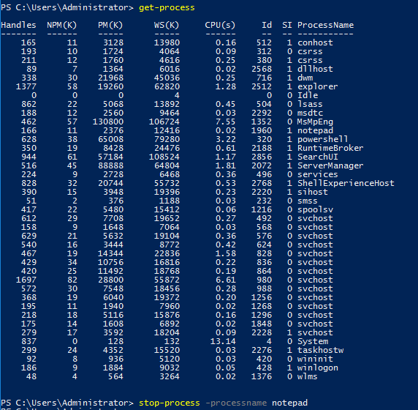

*Figure 9.* Stop-process cmdlet use to stop notepad

**Active Directory**

Active Directory is a centralized management database for devices and users on a network (TestOut Corp, 7.1.1). It provides the key benefit of managing multiple devices in a network from one location as opposed to going to each device individually to manage them. Organizational Units (OUs) can be created in a domain to better organize devices, users, and policies. This is done by configuring a domain controller with a copy of the Active Directory domain. Then, the devices and users are added to that domain so they can be managed. After they are added to the domain, they can be organized and managed to the standards of the organization.

To set up Active Directory, the first step is to select a device to be the domain controller and verify that its name is the correct one (TestOut Corp, 7.2.4). Next, the time zone needs to be set to the correct one. To do this, go to “Local Server” in Server Manager and select the time zone. Select “change date and time…” or “Change time zone…” on the “date and time” screen to change what is needed. This is important because Kerberos is the security protocol used by Active Directory and it can’t have more than five minutes of difference between clients in the domain.

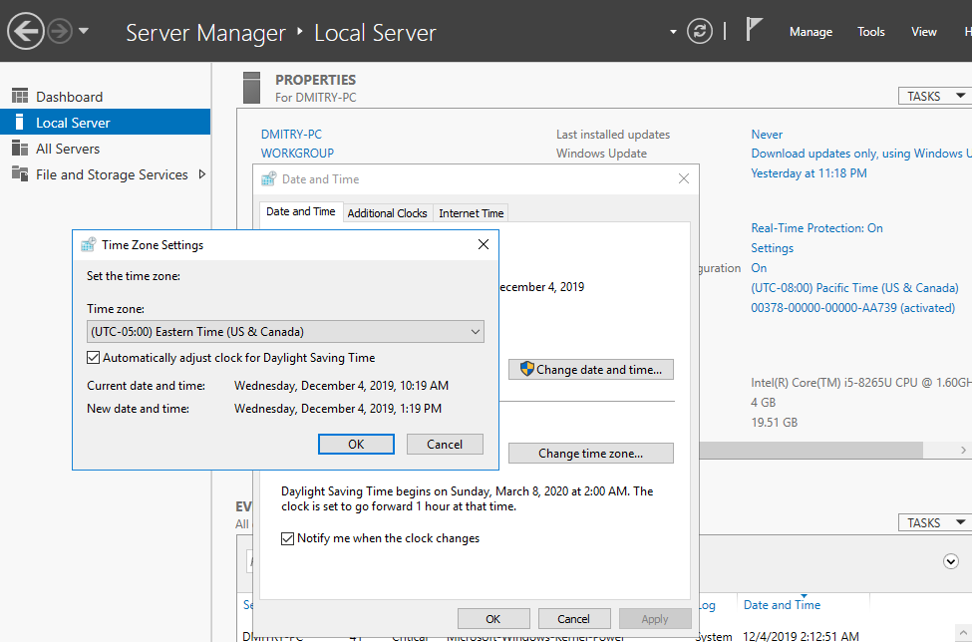

*Figure 10.* Time zone customization

The next step is to make sure that the domain controller’s IP address is static and the DNS IP address is correctly set (TestOut Corp, 7.2.4). To set the IP address, go to “Local Server” in Server Manager and select the blue link next to “Ethernet”. The “Network Connections” window will appear with the connection types. Right-click on the connection type and select “Properties”. Scroll down to “Internet Protocol Version 4”, select it and click on “properties”. A window will appear where the static IP address and DNS server IP addresses can be configured.

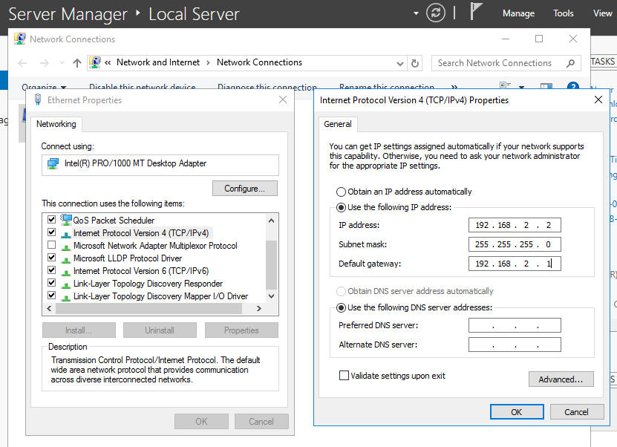

*Figure 11.* IPv4 Configuration window

The next step is to install the Active Directory role onto the computer. This is done by going to Server Manager and selecting “Manage” > “Add Roles and Features (ChrisAdmin, 2016). Select role-based for the installation type, click next, select the server, and click next. In the “Server Roles” section, select “Active Directory Domain Services”, click on “Add Features”, and then click on “next” until the last screen.

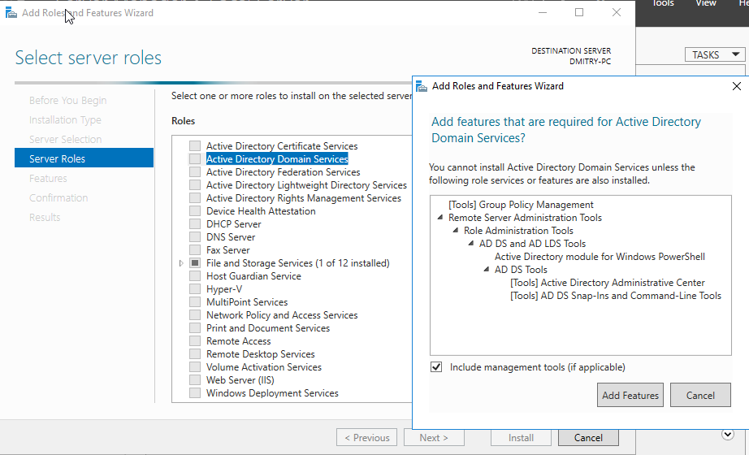

*Figure 12.* Active Directory role location

On the last screen, verify that the appropriate role is going to be installed and if it is, click on “Install”. After the installation is complete, a yellow mark will appear in the notification area. Select this notification and click on “Promote this server to a domain controller”. Since this is a new domain, select “Add a new forest” and input the root domain name. The next screen allows the server to be configured with some options. The functional level field specifies the oldest version of Windows Server that a domain controller in the domain and forest will be (TestOut Corp, 7.2.4). A password should be set up for the Directory Service Restore Mode in case Active Directory doesn’t function properly and has to be loaded in restore mode for troubleshooting.

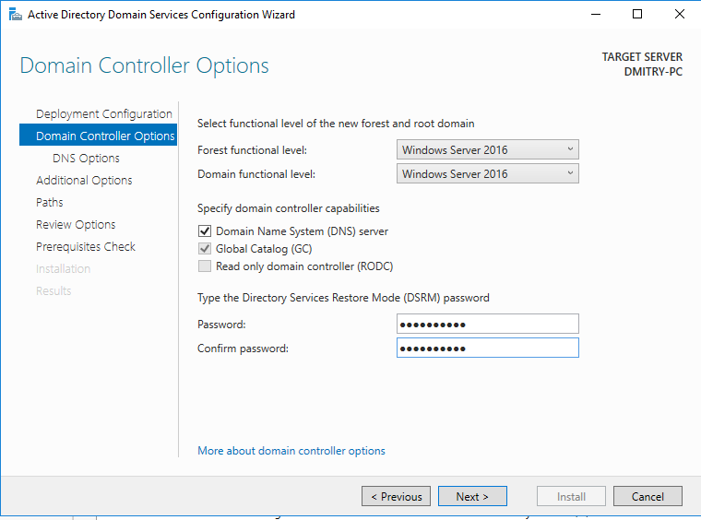

*Figure 13.* Domain controller options screen

If the DNS capability was selected then the next screen will be for the DNS options. A delegation to allow the domain to integrate with the parent domain on the internet can be set up here if needed (TestOut Corp, 7.2.4). However, since the domain in this report will not be so this window will be passed by. The next screen is to change the NetBIOS name if needed. If no changes are needed, click “next”. The “paths” section of the process allows file paths to be specified for the location of the Active Directory Directory Service database, log files, and SYSVOL folder. If no changes need to be made, select “next” to review the installation summary. If everything is correct, then click “next” to conduct the prerequisites check. When the prerequisites check is completed and it’s successful, the installation can be completed by selecting “Install”. During the installation process, the system will have to restart.

After it has restarted, the user should log in to make sure the role has restarted. The first noticeable change is that the login screen now shows “Administrator” along with the domain name. In the Server Manager, the domain has been updated, “AD DS” is now on the left side of the screen, and Active Directory tools are available in the “tools” of Server Manager.

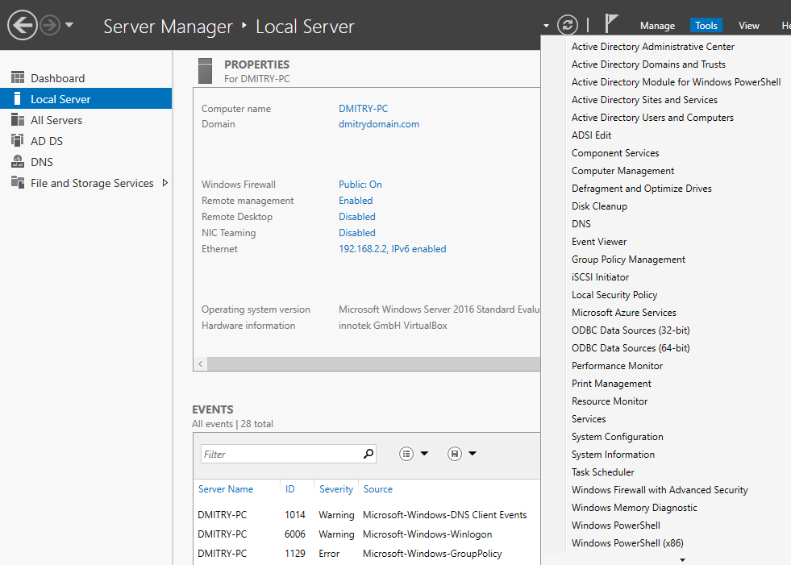

*Figure 14.* Additional tools and functions available after Active Directory installation

**Internet Information Services (IIS)**

Internet Information Services (IIS) is a role added to a server that allows it to function as a web server and service HTML requests (Rouse, 2008). Users in the LAN or WAN can connect to an IIS server to retrieve HTML web pages through HTTP or HTTPS. The extend to the IIS server functionality depends on the version of IIS installed.

IIS can be installed on Windows Server 2016 using the desktop environment through Server Manager. In Server Manager, select “Manage” and “Add roles and features” to begin the installation (Jarrod, 2016). Select role-base for the installation type and click “next”. In the next window select the desired server to install IIS on and go to the next step. In the “Server Roles” page, select “Web Server (IIS)” and click on “Add Features”. Click on “next” until reaching the “Role Services” page. In this step, the specific configurations of a web server such as file transfer and security features can be selected. This is not something that has to be figured out immediately as additional changes can be made after the installation. Once the role services have been figured out, click on “next” and then “Install” after confirming the installation. After the IIS role has been installed, additional configurations can be made to customize the server to provide all the appropriate functions. 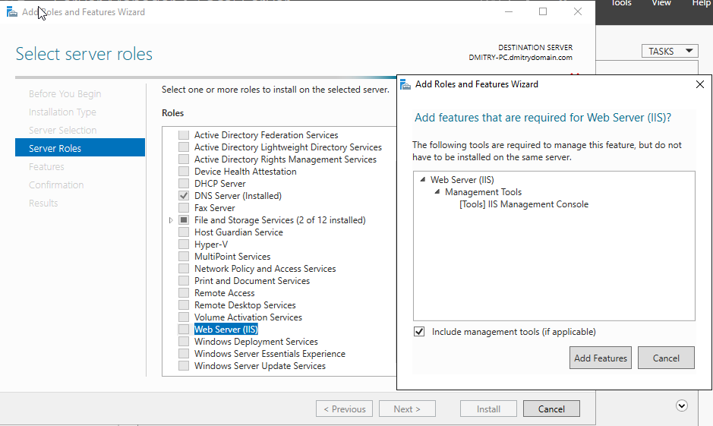

*Figure 15.* Web Server (IIS) location

**Chrome and Firefox**

By default, Windows Server 2016 is installed with Internet Explorer as the default web browser. Additional web browsers can be installed, such as Google Chrome and Firefox, by going to the browser’s website and downloading the installation files. Prior to downloading the browsers, Internet Explorers security settings need to be customized to allow the downloads to occur (Heinrichs, 2010). To do this, open Internet Explorer, select the gear icon in the top right and go to Internet Options. In this window, select the “Internet” icon and select “custom level”. Then, scroll down to “Downloads” and under “file download” select “enable”. This will allow the browser installation files to be downloaded.

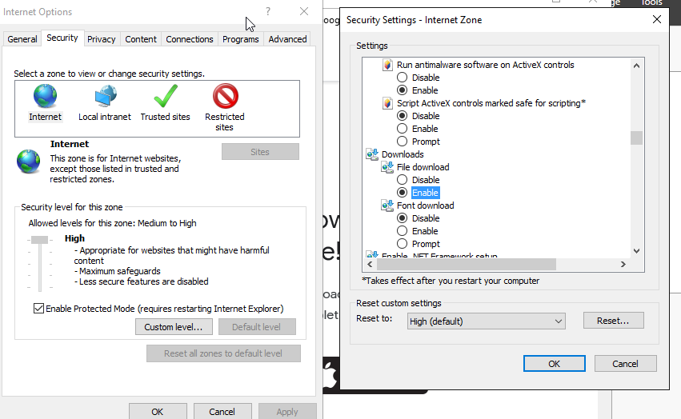

*Figure 16.* Security settings for Internet zone in Internet Explorer

To download Google Chrome use the following steps:

1. Open Internet Explorer
2. Go to https://www.google.com/chrome/
3. Select “ Download Chrome” and click “Accept and Install”
4. Select “Save” when the message box to download it comes up
5. Select the downloaded file and run ChromeSetup.exe

To Download Firefox use the following steps:

1. Open Internet Explorer
2. Go to https://www.mozilla.org/en-US/firefox/
3. Select” Download Firefox”
4. Select “Save when the message box to download the file comes up
5. Select the download file and run Firefox Installer.exe

After a new browser has been downloaded, the security settings must be adjusted appropriately to meet the organization's security standards. Each new browser will have to be configured individually and carefully.

**Summary**

This installation report provided the necessary steps to download the Windows Server 2016 ISO file, install Windows Server 2016 with the desktop environment, discuss the “get-process” and “stop-process” PowerShell cmdlets, install and configure Active Directory, install Internet Information Services, and download Chrome and Firefox. The ISO download section used the evaluation copy of Windows Server 2016 and only allows full functionality for 180 days. Once the limit is reached then a full copy will have to be purchased. The installation process walked through each step necessary to install Windows Server 2016 with the desktop version. The PowerShell section gave an overview of the “get-process” and “stop-process” cmdlets. This only served to provide an understanding of PowerShell. A more in-depth understanding of PowerShell and its cmdlets is needed to fully use PowerShell and all that is has to offer. Both the Active Directory and IIS sections provided steps to install the roles onto the server to get them started. Many additional configurations should be made to both before deploying either service in a true production environment. Chrome and Firefox installation steps were discussed to get both browsers onto the server. These browsers are downloaded with default settings that will need to be changed to meet the security standards of the organization. Following the steps provided in this report will give a user the basic understanding needed to use the desktop environment of Windows Server 2016.

References

ChrisAdmin. (2016). Setup Active Directory on Windows Server 2016. Retrieved from http://pc-addicts.com/setup-active-directory-server-2016/

Gavin, B. (2018). What Is An ISO File (And How Do I Use Them)? Retrieved from https://www.howtogeek.com/356714/what-is-an-iso-file-and-how-do-i-open-one/

Heinrichs, J. (2010). Your Current Security Settings Do Not Allow This File to be Downloaded. Retrieved from http://jaredheinrichs.com/your-current-security-settings-do-not-allow-this-file-to-be-downloaded.html

Jarrod. (2016). How To Install IIS In Windows Server 2016. Retrieved from https://www.rootusers.com/how-to-install-iis-in-windows-server-2016/

Microsoft. (2017). Getting Started with Windows PowerShell. Retrieved from https://docs.microsoft.com/en-us/powershell/scripting/getting-started/getting-started-with-windows-powershell

Posey, B. (2016). https://redmondmag.com/articles/2016/11/17/get-info-on-server-processes.aspx

Rouse, M. (2008). Internet Information Services (IIS). Retrieved from https://searchwindowsserver.techtarget.com/definition/IIS

TestOut Corp. (2019). TestOut Server Pro 2016: Install and Storage (section 2.2.1). Retrieved from http://www.testout.com

TestOut Corp. (2019). TestOut Server Pro 2016: Install and Storage (section 2.2.4). Retrieved from http://www.testout.com

TestOut Corp. (2019). TestOut Server Pro 2016: Install and Storage (section 7.2.4). Retrieved from http://www.testout.com

Tkachenko, S. (2016). How to end a process with PowerShell. Retrieved from https://winaero.com/blog/how-to-end-a-process-with-powershell/